URDHËR
Nr. 425, datë 16.10.2020

PËR PËRCAKTIMIN E FORMATIT TË APLIKIMIT DHE KUNDËRSHTIMIT TË PRODUKTEVE BUJQËSORE OSE USHQIMORE SI SPECIALITET TRADICIONAL I GARANTUAR

Në mbështetje të nenit 102, pika 4, të Kushtetutës; të pikës 8, të nenit 19 dhe nenit 8, të ligjit nr. 8/2019, datë 26.2.2019 “Për skemat e cilësisë së produkteve bujqësore dhe ushqimore”, me propozim të Drejtorisë së Politikave dhe Strategjive të Bujqësisë, Sigurisë Ushqimore dhe Zhvillimit Rural,

URDHËROJ:

1. Përcaktimin e formatit të aplikimit dhe kundërshtimit, të një produkti bujqësor ose ushqimor si Specialitet Tradicional i Garantuar (STG) për brenda vendit dhe në BE, sipas anekseve përkatëse bashkëlidhur.
2. Për zbatimin e këtij urdhri ngarkohet Drejtoria e Politikave dhe Strategjive të Bujqësisë, Sigurisë Ushqimore dhe Zhvillimit Rural.
3. Ky urdhër hyn në fuqi pas botimit në Fletoren Zyrtare.

MINISTËR I BUJQËSISË DHE ZHVILLIMIT RURAL
Bledar Çuçi
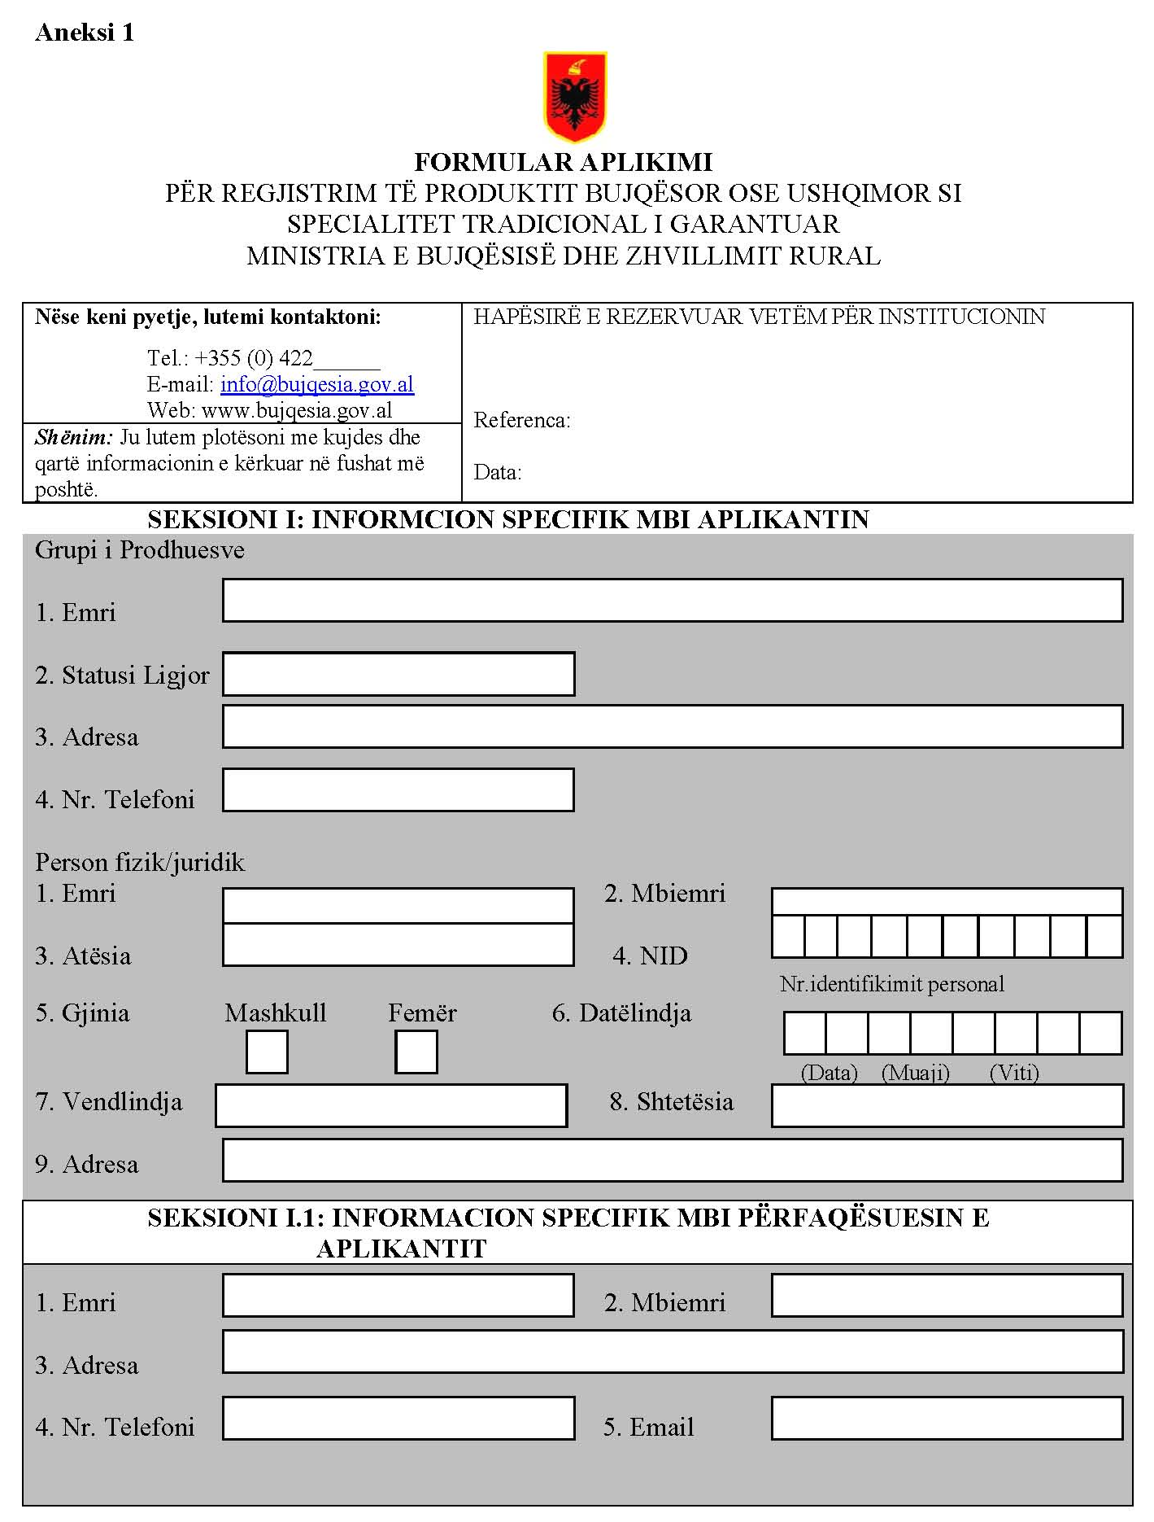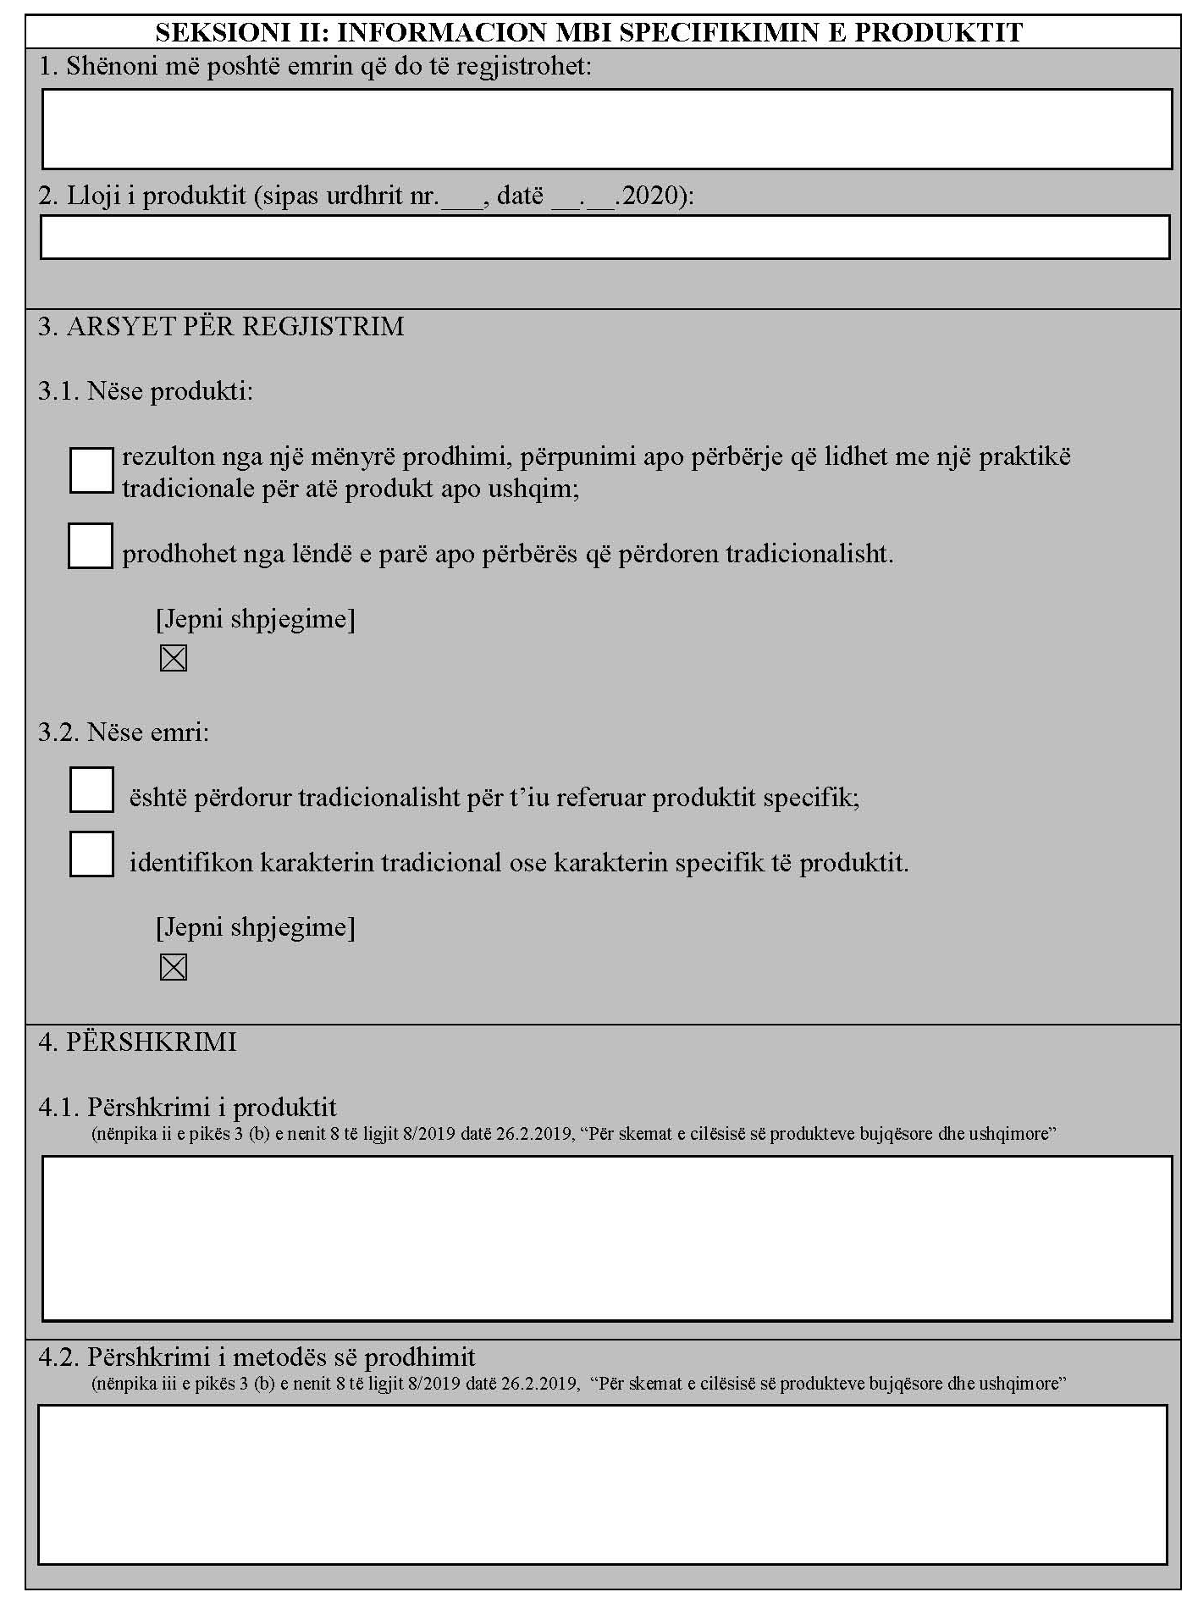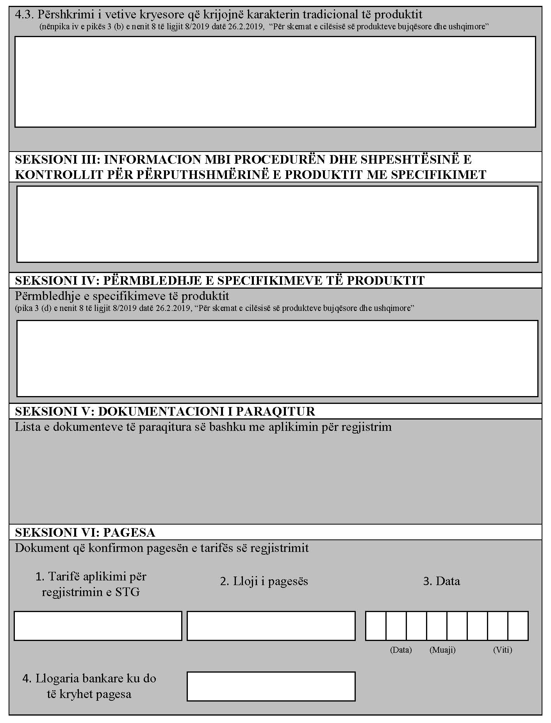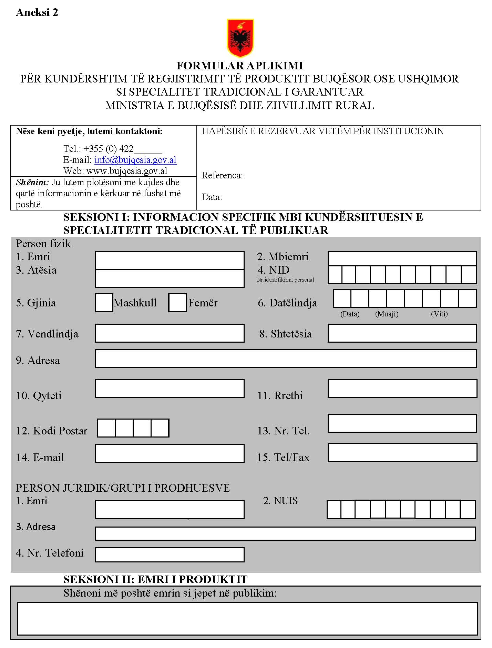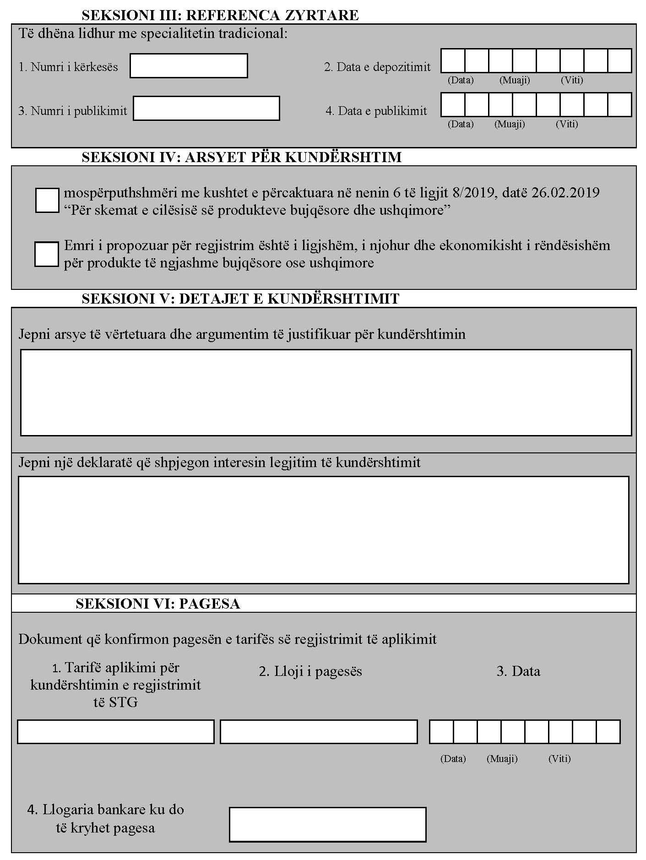

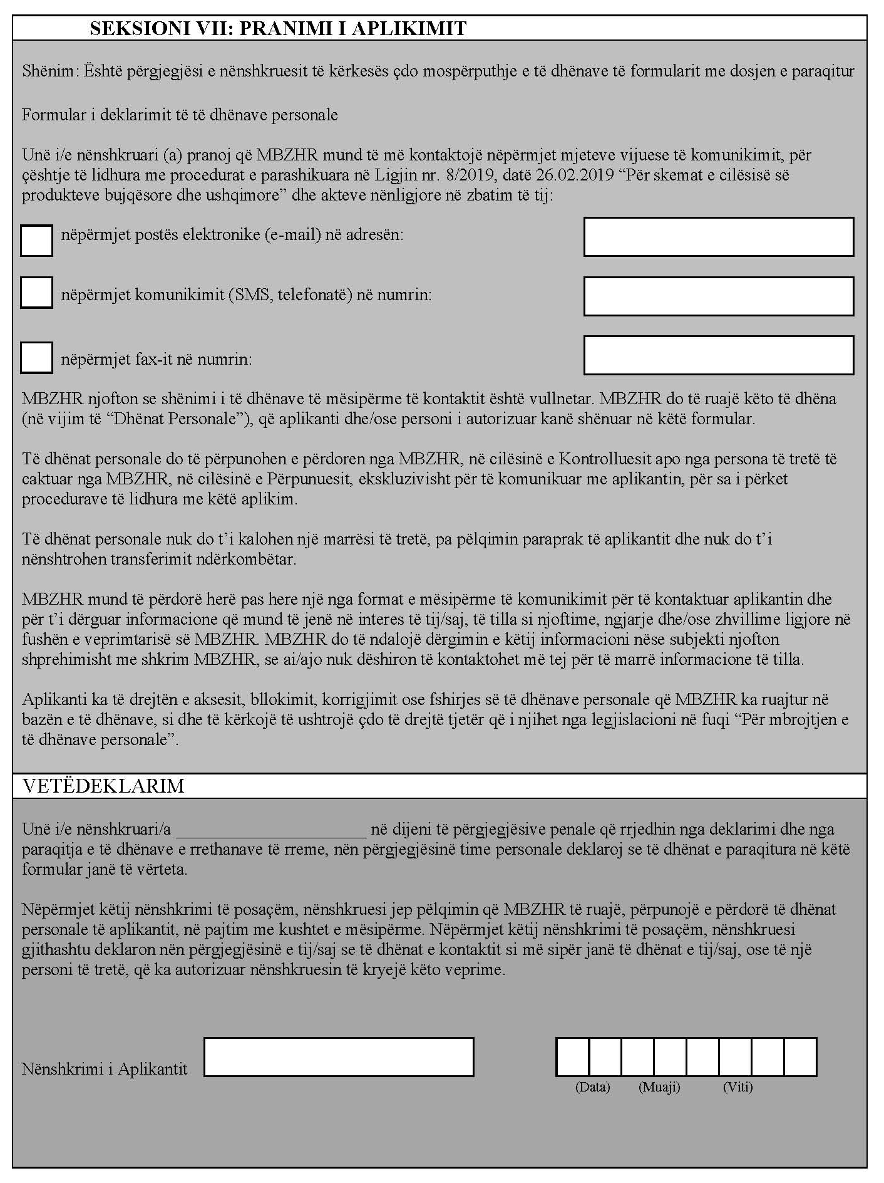
Aneksi 3

REGISTRATION APPLICATION FOR AGRICULTURAL PRODUCT
OR FOODSTUFF AS TRADITIONAL SPECIALTIES GUARANTEED

I. APPLICANT'S DETAILS
1. NAME:
2. REGISTERED OFFICE, ADDRESS, CONTACT DETAILS:
3. NAME AND SURNAME OF THE PERSON ACTING ON BEHALF OF THE APPLICANT:
4. GROUP:

II. PRODUCT SPECIFICATION
1. NAME(S) TO BE REGISTERED
….

2. TYPE OF PRODUCT [AS IN MINISTER’S ORDER]
….

3. GROUNDS FOR REGISTRATION
3.1 Whether the product:
results from a mode of production, processing or composition corresponding to traditional practice for that product or foodstuff
is produced from raw materials or ingredients that are those traditionally used.
[Provide explanation]

3.2 Whether the name:
has been traditionally used to refer to the specific product
identifies the traditional character or specific character of the product
[Provide explanation]

4. DESCRIPTION
4.1 Description of the product to which the name under point 1 applies, including its main physical, chemical, microbiological or organoleptic characteristics showing the product’s specific character (Article 8 Paragraph 3 b ii of the Law No. 8/2019, dated 26 February 2019, “On Quality Schemes of Agricultural and Food Products”)
4.2 Description of the production method of the product to which the name under point 1 applies that the producers must follow including, where appropriate, the nature and characteristics of the raw materials or ingredients used, and the method by which the product is prepared (Article 8 Paragraph 3 b iii of the Law No. 8/2019, dated 26 February 2019, “On Quality Schemes of Agricultural and Food Products”)
4.3 Description of the key elements establishing the product's traditional character (Article 8 Paragraph 3 point b iv of the Law No. 8/2019, dated 26 February 2019, “On Quality Schemes of Agricultural and Food Products”)

III. INFORMATION ON THE PROCEDURE AND FREQUENCY OF THE PRODUCT COMPLIANCE CHECK WITH THE SPECIFICATION
IV. SUMMARY OF THE PRODUCT SPECIFICATIONS
In particular the data as specified in points 3, letter “b”, items i-iv of the article 8 of the Law no. 8/2019, dated 26 February 2019, “On quality schemes of agricultural and food products”
V. THE LIST OF DOCUMENTS SUBMITTED TOGETHER WITH THE APPLICATION FOR REGISTRATION
VI. DOCUMENT CONFIRMING THE PAYMENT OF THE FEE FOR REGISTRATION

STATEMENT OF OPPOSITION FOR TSG APPLICATION

1. NAME OF PRODUCT
[as given in publication]
“…”

2. OFFICIAL REFERENCE
[as given in publication]
Date of publication: …

3. CONTACT DETAILS

Contact person: Title (Mr., Ms.…): … Name: …
Group/organization/individual: …
Address: …
Telephone + …
E-mail address: …

4. REASON FOR THE OPPOSITION:

Non-compliance with the conditions laid down in Article 6 of the Law no. 8/2019, dated 26 February 2019, “On quality schemes of agricultural and food products”

The name proposed for registration is lawful, renowned and economically significant for similar agricultural products or foodstuffs

5. DETAIL OF OPPOSITION

Provide duly substantiated reasons and justification for the opposition.
Provide also a statement explaining the legitimate interest of the opposition

The statement of opposition should be signed and dated.

