VENDIM
Nr. 45, datë 22.1.2020

PËR SHPALLJEN E ZONËS SË RE PËR ZHVILLIM NË NJËSINË ADMINISTRATIVE SHIJAK, BASHKIA SHIJAK, DHE CAKTIMIN E FONDIT SHQIPTAR TË ZHVILLIMIT SI NJËSI ZBATUESE

Në mbështetje të nenit 100 të Kushtetutës dhe të neneve 13, shkronja “b”, nënndarjet “iii” e “iv”, dhe 16, pika 3, të aktit normativ nr. 9, datë 16.12.2019, të Këshillit Ministrave, “Për përballimin e pasojave të fatkeqësisë natyrore”, miratuar me ligjin nr. 97/2019, me propozimin e ministrit të Shtetit për Rindërtimin, Këshilli i Ministrave

VENDOSI:

1. Shpalljen si zonë e përshtatshme për zhvillimin e detyruar, “Zonë të re për zhvillim” të zonës 1, Njësia Administrative Shijak, Bashkia Shijak, sipas hartës dhe koordinatave bashkëlidhur këtij vendimi.
2. Fondi Shqiptar i Zhvillimit caktohet si njësi zbatuese për këtë zonë, për:
a) ndërtimin e banesave të reja ose të ndërtesave publike të dëmtuara;
b) ndërtimin dhe rikonstruksionin e infrastrukturës publike e kritike;
c) realizimin e ndërtimeve në këtë zonë;
ç) çdo ndërhyrje tjetër, në funksion të rindërtimit të kësaj zone.
3. Ngarkohen ministri i Shtetit për Rindërtimin, Fondi Shqiptar i Zhvillimit, Bashkia Shijak dhe Agjencia Kombëtare e Planifikimit të Territorit për zbatimin e këtij vendimi.
Ky vendim hyn në fuqi menjëherë dhe botohet në Fletoren Zyrtare.

KRYEMINISTËR
Edi Rama

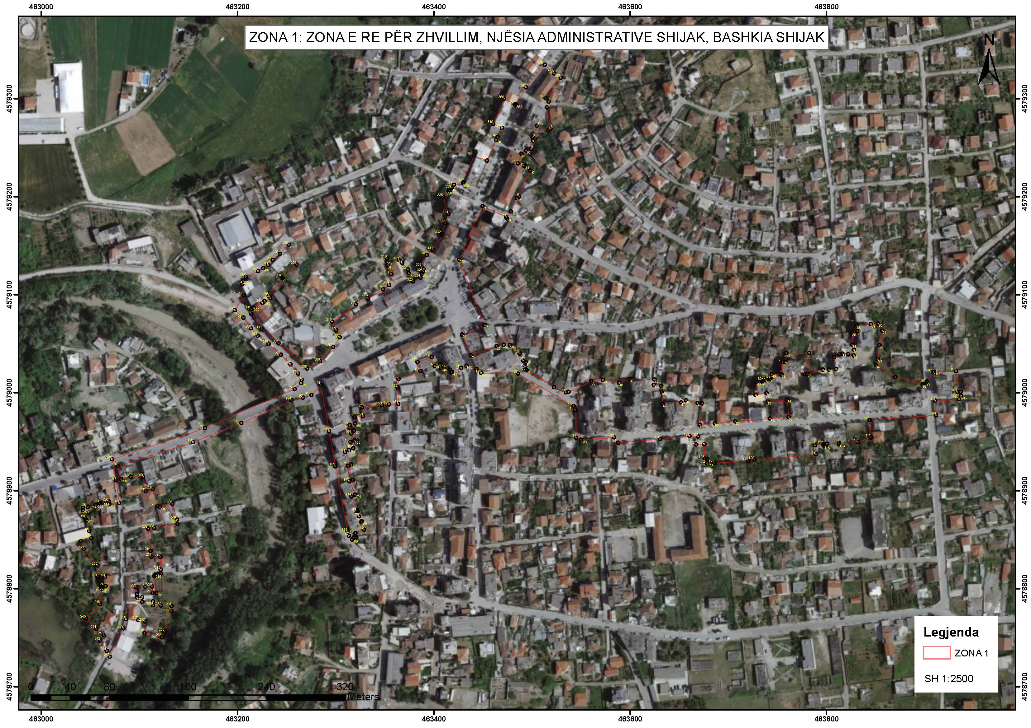

ID | X_Coordinate | Y_Coordinate
1 | 379872.1722 | 4578368.141
2 | 379870.4097 | 4578362.347
3 | 379873.759 | 4578340.419
4 | 379871.4122 | 4578338.947
5 | 379860.0253 | 4578343.768
6 | 379855.3751 | 4578331.778
7 | 379857.6183 | 4578330.122
8 | 379855.6653 | 4578328.607
9 | 379853.6231 | 4578320.215
10 | 379848.7716 | 4578318.5
11 | 379843.777 | 4578314.867
12 | 379840.0897 | 4578305.501
13 | 379846.6792 | 4578302.351
14 | 379847.5227 | 4578303.126
15 | 379852.3257 | 4578297.901
16 | 379840.8459 | 4578271.626
17 | 379838.7776 | 4578270.01
18 | 379832.3382 | 4578256.585
19 | 379828.0783 | 4578249.555
20 | 379827.3498 | 4578250.959
21 | 379803.535 | 4578262.337
22 | 379779.059 | 4578207.757
23 | 379804.0914 | 4578141.208
24 | 379781.2879 | 4578131.456
25 | 379789.9304 | 4578110.31
26 | 379816.2501 | 4578119.11
27 | 379823.547 | 4578120.571
28 | 379829.7074 | 4578120.063
29 | 379839.6856 | 4578111.604
30 | 379842.9033 | 4578104.212
31 | 379846.115 | 4578102.222
32 | 379844.5657 | 4578098.184
33 | 379845.3006 | 4578095.67
34 | 379846.4021 | 4578094.62
35 | 379874.2773 | 4578076.75
36 | 379886.5242 | 4578071.281
37 | 379889.0976 | 4578071.842
38 | 379912.3088 | 4578082.354
39 | 379924.228 | 4578083.453
40 | 379940.673 | 4578080.457
41 | 379951.6616 | 4578084.332
42 | 379976.6874 | 4578083.297
43 | 379975.9154 | 4578077.949
44 | 379983.5322 | 4578076.852
45 | 379983.8033 | 4578070.613
46 | 379984.7576 | 4578058.324
47 | 380003.4785 | 4578059.698
48 | 380008.6785 | 4578061.762
49 | 380020.3431 | 4578058.866
50 | 380024.9585 | 4578058.432
51 | 380022.622 | 4578036.611
52 | 380037.5629 | 4578037.772
53 | 380058.6046 | 4578039.561
54 | 380094.0633 | 4578042.261
55 | 380112.8473 | 4578043.281
56 | 380111.5682 | 4578061.264
57 | 380091.7377 | 4578059.603
58 | 380090.7962 | 4578067.952
59 | 380079.4124 | 4578066.668
60 | 380080.7702 | 4578079.43
61 | 380085.9707 | 4578079.801
62 | 380085.8982 | 4578080.818
63 | 380086.6894 | 4578081.56
64 | 380089.8315 | 4578081.784
65 | 380089.803 | 4578082.183
66 | 380094.1084 | 4578082.49
67 | 380095.3069 | 4578082.751
68 | 380096.2087 | 4578087.552
69 | 380106.0886 | 4578086.989
70 | 380107.4039 | 4578099.765
71 | 380109.8979 | 4578099.939
72 | 380111.3197 | 4578108.593
73 | 380134.5589 | 4578108.593
74 | 380129.5405 | 4578087.324
75 | 380132.4857 | 4578087.219
76 | 380148.2944 | 4578091.505
77 | 380154.3637 | 4578091.505
78 | 380161.8654 | 4578092.027
79 | 380160.0192 | 4578104.14
80 | 380165.5274 | 4578106.931
81 | 380168.2433 | 4578107.609
82 | 380174.2848 | 4578106.793
83 | 380179.8409 | 4578105.52
84 | 380179.9873 | 4578111.451
85 | 380178.819 | 4578116.539
86 | 380178.5157 | 4578128.584
87 | 380183.7272 | 4578130.355
88 | 380183.2647 | 4578136.036
89 | 380197.7534 | 4578137.205
90 | 380205.2255 | 4578137.862
91 | 380209.2617 | 4578130.445
92 | 380206.1717 | 4578115.757
93 | 380204.4703 | 4578101.576
94 | 380202.3308 | 4578095.531
95 | 380222.1024 | 4578083.019
96 | 380249.5304 | 4578075.465
97 | 380251.3847 | 4578076.314
98 | 380252.2565 | 4578077.165
99 | 380253.3712 | 4578077.36
100 | 380253.959 | 4578078.198
101 | 380260.6753 | 4578087.772
102 | 380261.4109 | 4578087.788
103 | 380284.0647 | 4578088.292
104 | 380284.9427 | 4578067.208
105 | 380288.6398 | 4578067.111
106 | 380288.6398 | 4578063.143
107 | 380286.7721 | 4578059.707
108 | 380262.1036 | 4578058.335
109 | 380263.0223 | 4578043.551
110 | 380195.2091 | 4578039.585
111 | 380196.3811 | 4578021.826
112 | 380183.0684 | 4578017.036
113 | 380164.0184 | 4578015.614
114 | 380163.8188 | 4578016.7
115 | 380151.3849 | 4578015.91
116 | 380148.9318 | 4578013.959
117 | 380147.7694 | 4578015.42
118 | 380139.2158 | 4578014.46
119 | 380140.0454 | 4578005.155
120 | 380077.5225 | 4578000.252
121 | 380071.4571 | 4577999.098
122 | 380036.6815 | 4577997.448
123 | 380029.2911 | 4577997.521
124 | 380029.3178 | 4578001.453
125 | 380026.8091 | 4578002.092
126 | 380026.8091 | 4578016.627
127 | 380018.3542 | 4578016.627
128 | 380020.1357 | 4578024.813
129 | 380011.8379 | 4578025.028
130 | 379981.8115 | 4578022.477
131 | 379939.0455 | 4578019.448
132 | 379934.907 | 4578024.701
133 | 379901.0342 | 4578022.715
134 | 379896.0556 | 4578024.999
135 | 379895.9454 | 4578052.833
136 | 379893.9813 | 4578057.155
137 | 379837.6646 | 4578091.086
138 | 379800.4173 | 4578091.827
139 | 379795.4273 | 4578096.198
140 | 379785.3108 | 4578099.827
141 | 379779.889 | 4578097.5
142 | 379770.6996 | 4578093.556
143 | 379769.5509 | 4578093.063
144 | 379768.4269 | 4578095.682
145 | 379766.22 | 4578097.401
146 | 379759.5904 | 4578097.575
147 | 379758.4058 | 4578101.262
148 | 379752.9442 | 4578099.506
149 | 379749.9612 | 4578108.789
150 | 379735.5712 | 4578104.165
151 | 379738.4302 | 4578094.911
152 | 379715.9463 | 4578086.845
153 | 379715.0506 | 4578078.184
154 | 379715.406 | 4578061.66
155 | 379706.1094 | 4578061.047
156 | 379698.7882 | 4578060.397
157 | 379678.5314 | 4578058.345
158 | 379679.2782 | 4578049.376
159 | 379670.7673 | 4578048.667
160 | 379671.0955 | 4578042.075
161 | 379665.7956 | 4578040.606
162 | 379666.6775 | 4578037.426
163 | 379670.0869 | 4578034.805
164 | 379667.2458 | 4578031.745
165 | 379670.3847 | 4578024.604
166 | 379666.4024 | 4578022.853
167 | 379669.0761 | 4578016.784
168 | 379664.7802 | 4578014.894
169 | 379660.659 | 4578013.083
170 | 379666.2851 | 4578000.284
171 | 379663.6254 | 4577999.115
172 | 379668.0608 | 4577984.432
173 | 379664.7502 | 4577983.018
174 | 379670.5834 | 4577969.362
175 | 379666.642 | 4577967.515
176 | 379672.3168 | 4577953.434
177 | 379672.7751 | 4577952.381
178 | 379671.8625 | 4577951.984
179 | 379673.9901 | 4577947.003
180 | 379676.1505 | 4577941.945
181 | 379677.1583 | 4577942.157
182 | 379678.9636 | 4577933.586
183 | 379670.4244 | 4577930.147
184 | 379671.1169 | 4577925.776
185 | 379669.1093 | 4577925.776
186 | 379666.7878 | 4577923.727
187 | 379663.6031 | 4577927.626
188 | 379662.1346 | 4577931.989
189 | 379650.6212 | 4577998.459
190 | 379644.4868 | 4578034.502
191 | 379636.626 | 4578081.881
192 | 379626.9984 | 4578071.481
193 | 379618.1881 | 4578069.08
194 | 379606.6696 | 4578066.552
195 | 379555.4124 | 4578043.928
196 | 379505.9558 | 4578024.862
197 | 379428.8957 | 4578001.38
198 | 379432.3407 | 4577988.006
199 | 379441.96 | 4577990.347
200 | 379454.5331 | 4577990.19
201 | 379457.1875 | 4577975.283
202 | 379464.4885 | 4577977.375
203 | 379468.7732 | 4577960.014
204 | 379471.3751 | 4577958.993
205 | 379484.2203 | 4577962.108
206 | 379488.5107 | 4577945.961
207 | 379489.0105 | 4577941.675
208 | 379465.3391 | 4577937.743
209 | 379458.8992 | 4577937.206
210 | 379461.3727 | 4577914.534
211 | 379462.4243 | 4577908.627
212 | 379471.4369 | 4577908
213 | 379471.3042 | 4577895.265
214 | 379471.7295 | 4577891.369
215 | 379468.9875 | 4577891.07
216 | 379466.0979 | 4577890.25
217 | 379465.0273 | 4577888.674
218 | 379466.6185 | 4577871.46
219 | 379462.9352 | 4577871.525
220 | 379462.4865 | 4577878.289
221 | 379455.6526 | 4577877.823
222 | 379446.4082 | 4577877.394
223 | 379446.8599 | 4577870.429
224 | 379447.199 | 4577870.451
225 | 379447.2984 | 4577866.999
226 | 379452.2683 | 4577867.142
227 | 379452.3101 | 4577862.788
228 | 379463.1888 | 4577862.893
229 | 379463.3491 | 4577859.002
230 | 379471.1018 | 4577858.785
231 | 379482.2172 | 4577858.014
232 | 379481.9604 | 4577852.743
233 | 379474.5142 | 4577832.174
234 | 379471.7922 | 4577826.594
235 | 379454.2711 | 4577830.835
236 | 379454.8897 | 4577842.444
237 | 379447.8085 | 4577844.35
238 | 379435.6748 | 4577844.997
239 | 379432.771 | 4577835.751
240 | 379418.5884 | 4577807.035
241 | 379415.5139 | 4577813.176
242 | 379409.0211 | 4577823.584
243 | 379412.6499 | 4577829.207
244 | 379405.2032 | 4577835.751
245 | 379394.9533 | 4577846.264
246 | 379409.2348 | 4577860.94
247 | 379411.0738 | 4577876.714
248 | 379411.0316 | 4577879.014
249 | 379415.1273 | 4577879.179
250 | 379414.7539 | 4577888.459
251 | 379407.1123 | 4577888.459
252 | 379407.1123 | 4577900.17
253 | 379393.4486 | 4577917.299
254 | 379390.3949 | 4577925.451
255 | 379401.1769 | 4577928.365
256 | 379399.2425 | 4577935.522
257 | 379396.1699 | 4577946.975
258 | 379395.0872 | 4577948.728
259 | 379392.9672 | 4577957.044
260 | 379393.3274 | 4577959.233
261 | 379397.9023 | 4577960.266
262 | 379405.9097 | 4577961.912
263 | 379409.9605 | 4577962.471
264 | 379409.7557 | 4577963.787
265 | 379413.8884 | 4577964.43
266 | 379419.4786 | 4577965.37
267 | 379419.9042 | 4577962.837
268 | 379429.9444 | 4577963.777
269 | 379426.8446 | 4577987.068
270 | 379423.2733 | 4578008.326
271 | 379518.1928 | 4578039.084
272 | 379610.1357 | 4578077.779
273 | 379616.8725 | 4578083.977
274 | 379617.4613 | 4578087.069
275 | 379613.7737 | 4578093.654
276 | 379606.1334 | 4578103.04
277 | 379596.3967 | 4578112.988
278 | 379584.12 | 4578124.418
279 | 379573.1133 | 4578132.885
280 | 379566.34 | 4578140.293
281 | 379558.72 | 4578151.3
282 | 379550.0416 | 4578158.92
283 | 379559.3011 | 4578174.332
284 | 379557.9848 | 4578185.189
285 | 379558.7282 | 4578189.086
286 | 379561.661 | 4578192.865
287 | 379574.1776 | 4578198.713
288 | 379579.5711 | 4578201.56
289 | 379584.2803 | 4578204.847
290 | 379589.192 | 4578209.923
291 | 379596.869 | 4578216.02
292 | 379605.8674 | 4578225.158
293 | 379613.466 | 4578204.786
294 | 379598.1159 | 4578192.23
295 | 379599.0379 | 4578191.193
296 | 379584.8331 | 4578173.239
297 | 379586.2231 | 4578170.99
298 | 379580.4146 | 4578167.632
299 | 379577.9121 | 4578166.268
300 | 379569.1476 | 4578161.35
301 | 379566.3795 | 4578159.797
302 | 379566.7633 | 4578154.898
303 | 379577.135 | 4578139.447
304 | 379594.0684 | 4578124.63
305 | 379622.8692 | 4578098.603
306 | 379636.2633 | 4578105.891
307 | 379649.8232 | 4578120.443
308 | 379656.4683 | 4578130.032
309 | 379653.073 | 4578137.173
310 | 379648.8163 | 4578146.127
311 | 379673.2528 | 4578163.481
312 | 379685.7345 | 4578169.685
313 | 379701.4148 | 4578178.586
314 | 379707.476 | 4578182.881
315 | 379709.8391 | 4578193.816
316 | 379706.1601 | 4578202.884
317 | 379705.3999 | 4578207.259
318 | 379705.7788 | 4578209.905
319 | 379717.7874 | 4578208.185
320 | 379721.0716 | 4578205.203
321 | 379726.7715 | 4578198.421
322 | 379727.4534 | 4578194.837
323 | 379731.6662 | 4578186.268
324 | 379739.4924 | 4578190.116
325 | 379741.2235 | 4578194.291
326 | 379742.0212 | 4578196.02
327 | 379742.8818 | 4578198.812
328 | 379740.7804 | 4578201.252
329 | 379746.0885 | 4578213.173
330 | 379752.2792 | 4578218.195
331 | 379762.1953 | 4578233.122
332 | 379760.7221 | 4578234.558
333 | 379765.4964 | 4578245.423
334 | 379768.5688 | 4578254.59
335 | 379763.498 | 4578272.252
336 | 379769.4028 | 4578278.257
337 | 379770.1509 | 4578279.44
338 | 379770.7426 | 4578279.066
339 | 379772.1586 | 4578281.306
340 | 379772.539 | 4578281.066
341 | 379774.6497 | 4578284.405
342 | 379784.03 | 4578285.643
343 | 379784.6277 | 4578287.072
344 | 379795.4318 | 4578314.148
345 | 379808.4414 | 4578308.592
346 | 379818.1942 | 4578329.435
347 | 379819.6461 | 4578332.538
348 | 379824.1398 | 4578341.875
349 | 379815.34 | 4578346.094
350 | 379826.6313 | 4578371.516
351 | 379837.3605 | 4578366.141
352 | 379839.0726 | 4578365.41
353 | 379848.9992 | 4578382.727
354 | 379868.6651 | 4578405.911
355 | 379877.9221 | 4578396.868
356 | 379884.7694 | 4578392.353
357 | 379869.1689 | 4578371.681
358 | 379872.1722 | 4578368.141

